# MSRS Software System Architecture:

## SW System Architecture for Single Arm:



### Robot App:

The Robot app is responsible for controlling the robot arm. This will allow the robotic arm to mimic the movements of the hand controls.

### Input Selector:

You can map a hand controller of your choice to a robot arm of your choice based on a foot pedal truth table.

### Input Shaper:

The user can choose a scaling factor and should apply a filter to the hand control's input data to achieve smooth movement.

### Instrument Handler:

Responsible for reading Instrument data and selecting desired configurations for actuators

### Safety Handler:

A safety controller refers to a software component or module that is responsible for enforcing safety rules and regulations within a system or application. It ensures that critical operations or processes adhere to safety guidelines and protocols, preventing potential hazards or accidents.

### Process Manager:

A process manager, also known as a task manager or process supervisor, is a software component or tool that oversees and manages the execution of processes on a computer system. Its primary role is to monitor and control the running processes, ensuring efficient resource utilization and system stability.

### Self Test:

In safety-critical systems, a self-test is a built-in mechanism that allows the system to verify its own functionality and detect potential faults or failures. These tests are essential to ensure that the system operates correctly and reliably, especially in critical situations where human lives or the environment could be at risk.

The primary purpose of self-tests in safety-critical systems is to identify and diagnose any faults or errors that may have occurred during the system's operation

### Push buttons & LEDs:

This module is responsible for implementing the arm mode state machine and controlling the LEDs on the robot.

### Logger:

Logging in software refers to the process of capturing and recording relevant events, information, and errors that occur during the execution of a software application. It helps developers and administrators understand the behavior of the software, diagnose issues, and monitor its performance

## SW System Architecture for Multi Arm:

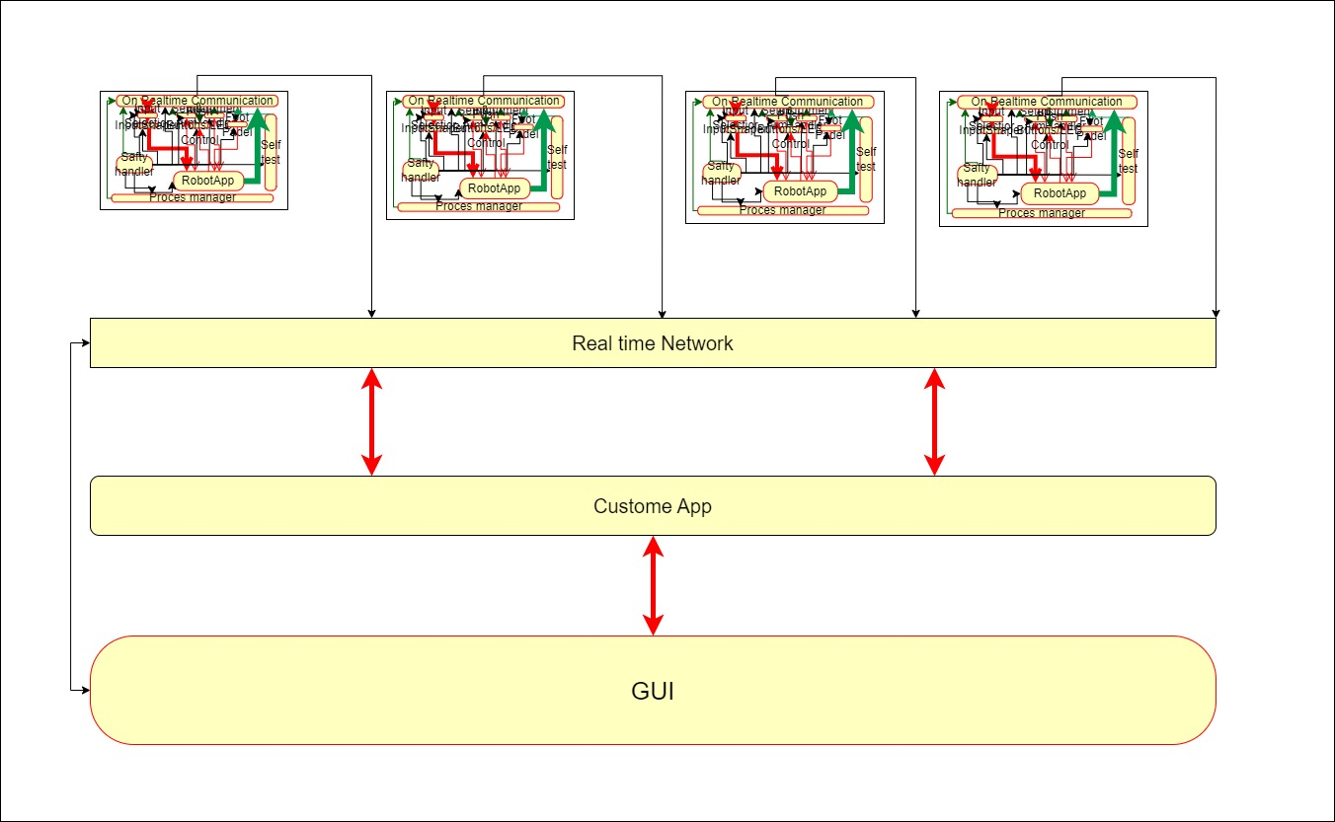

The multi-arm software system includes four single-arm architectures, custom apps and user interfaces.

## Custom App:

Interact with all robot apps on the network and render simulations.

A multi-arm robot simulation is a virtual representation of a robotic system that consists of multiple robotic arms or manipulators operating together within a simulated environment. These simulations are used to model and study the behavior and performance of robots with multiple arms, as well as their interactions with objects and their surroundings

### GUI:

The purpose of a 2D touch screen in a surgical robot system is to serve as a user interface for the surgeon or medical personnel to control and interact with the robotic system during surgery. It provides a visual representation of the robot's movements and functions, allowing the operator to manipulate the robotic arms and instruments with precision and ease.

Key purposes and functionalities of a 2D touch screen in a surgical robot system include:

System Control: The touch screen allows the surgeon to power on/off the robotic system, initialize the hardware, and establish communication between the surgeon and the robot.

Robot Arm Manipulation: Surgeons can control the movements of the robotic arms through the touch screen. By touching and dragging their fingers across the screen, they can position the robotic arms and instruments

Instrument Selection: The touch screen interface often includes options for selecting different surgical instruments and tools that are attached to the robotic arms. The surgeon can switch between instruments as needed during the procedure.

Zoom and Pan: During surgery, the surgeon may need to view specific areas in detail. The touch screen enables zooming in and out and panning across the surgical site, providing a clear and close-up view of the targeted area.

Camera Control: In robotic surgery, a camera is typically used to provide a visual feed of the surgical site. The touch screen allows the surgeon to control the camera's movement, adjusting the view as necessary.

Settings and Preferences: Surgeons can access and adjust various settings and preferences related to the robotic system, such as speed, sensitivity, and other parameters that influence the robot's behavior.

Emergency Stop: The touch screen often includes a prominent emergency stop button, allowing the surgeon to halt the robot's movements immediately in case of any unexpected situations or safety concerns.

Status Monitoring: The touch screen provides real-time feedback on the status of the robotic system, including the position of the robot's arms, instrument status, battery levels, and any system warnings or alerts.

Documentation and Patient Information: Some surgical robot systems allow the surgeon to access patient information, pre-operative planning data, and relevant medical records through the touch screen, aiding decision-making during the surgery.

Client App:

### Application:

Application are specific to individual client app for foot pedal /HMI ..

### Process Manager

A process manager, also known as a task manager or process supervisor, is a software component or tool that oversees and manages the execution of processes on a computer system. Its primary role is to monitor and control the running processes, ensuring efficient resource utilization and system stability. Here's an overview of the process manager's functions:

* Process Monitoring: The process manager constantly monitors the state of processes running on the system.
* Process Control: The process manager allows users to control processes by starting, stopping, pausing, or resuming them.
* Resource Allocation: The process manager manages system resources and allocates them to different processes based on their priority and requirements. It ensures that processes receive adequate CPU time, memory, disk space, and other resources, preventing resource contention and optimizing overall system performance.
* Process Prioritization: In a multitasking environment, the process manager assigns priority levels to processes. Higher-priority processes receive more CPU time, allowing critical tasks to be executed promptly. Prioritization helps balance resource allocation and responsiveness within the system.
* Process Scheduling: The process manager schedules the execution of processes based on various scheduling algorithms (e.g., round-robin, priority-based, or fair-share scheduling). It determines the order in which processes are executed, ensuring fairness, responsiveness, and efficient resource utilization.
* Process Termination: The process manager handles the termination of processes when they complete their tasks, encounter errors, or are explicitly terminated by the user. It ensures that resources held by terminated processes are released and the system remains stable.
* Process Dependency Management: Some processes may depend on the successful execution of other processes or specific system conditions. The process manager manages process dependencies and ensures that processes are launched or halted in the correct order to maintain proper functionality.
* System Health Monitoring: Alongside process management, modern process managers often provide system health monitoring features. They monitor system-wide metrics, including CPU load, memory usage, disk I/O, network activity, and temperature, alerting users to abnormal conditions or potential issues.

### MCX BASE:

TBD

### Safty Monitor:

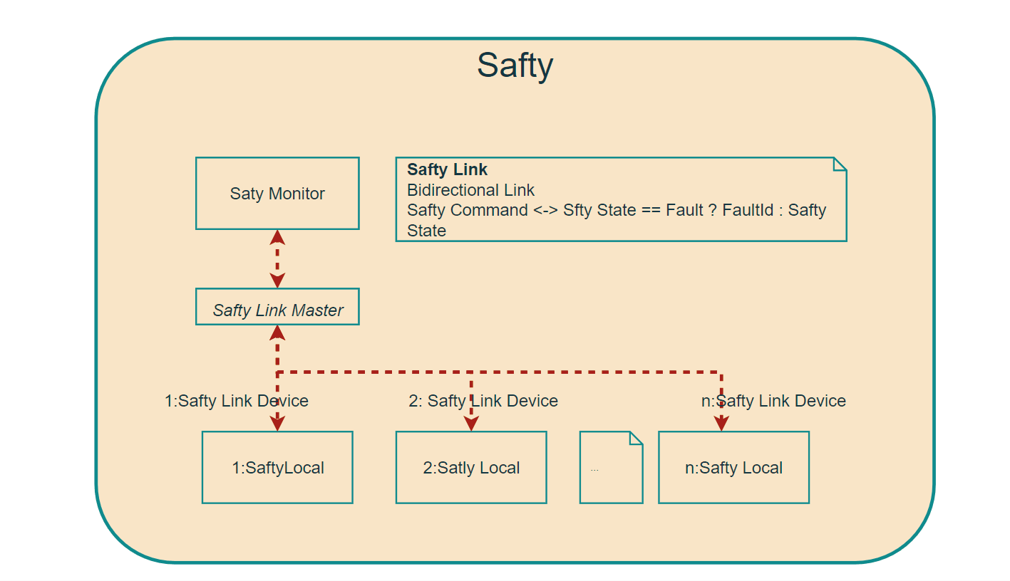





A safety controller refers to a software component or module that is responsible for enforcing safety rules and regulations within a system or application. It ensures that critical operations or processes adhere to safety guidelines and protocols, preventing potential hazards or accidents. Here are some key aspects of a safety controller in software:

1. Safety Compliance: The safety controller implements safety standards and regulations specific to the Application. It ensures that the software system complies with safety requirements and guidelines set by regulatory bodies or industry standards organizations.

2. Error Handling and Fault Tolerance: The safety controller monitors the software system for errors, exceptions, or faults that may compromise safety. It employs robust error handling mechanisms to detect and handle failures gracefully, preventing system crashes or unsafe conditions.

3. Input Validation and Sanitization: The safety controller validates and sanitizes user inputs to prevent security vulnerabilities such as buffer overflows, injection attacks, or data corruption. It ensures that inputs are within acceptable ranges and free from malicious content that could potentially harm the system.

4. Safety Critical Algorithms: In safety-critical systems, the safety controller implements algorithms or decision-making logic that prioritize safety over other considerations. It performs checks, calculations, or simulations to determine safe operating conditions and triggers appropriate actions in response to potential hazards.

5. Failure Detection and Recovery: The safety controller monitors the software system for failures, malfunctions, or abnormal conditions. It employs techniques like watchdog timers, redundancy, or error detection codes to detect failures and initiates recovery procedures to restore the system to a safe state.

6. Real-time Monitoring and Reporting: The safety controller continuously monitors the system's behavior, performance, and safety metrics in real-time. It generates reports, logs, or alerts to notify system administrators or operators about any safety concerns or deviations from the expected behavior.

7. Integration with Safety Devices or Systems: In some cases, the safety controller in software interfaces with physical safety devices or systems, such as emergency stop buttons, safety sensors, or alarm systems. It receives signals from these devices and triggers appropriate actions within the software system to ensure safety.

# DATA Model

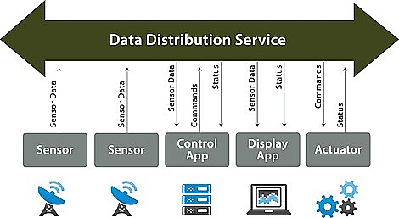

DDS (Data Distribution Service) is a middleware protocol that enables efficient and scalable data communication and integration in distributed systems. It provides a publish-subscribe model for real-time data exchange between different components or nodes in a network. While DDS is a communication protocol rather than a data modeling standard, it does have certain concepts and structures that can be associated with a data model. Here are some key aspects of data modeling in the context of DDS:

1. Topic: In DDS, a topic represents a specific type of data that is being published or subscribed to. It defines the structure and semantics of the data being exchanged. A topic can be thought of as a data model definition, describing the fields, data types, and relationships within the data.

2. Data Type: Data types define the structure and format of the data being communicated over DDS. DDS supports various built-in data types, including primitive types (integer, float, boolean), strings, arrays, and sequences. Additionally, DDS allows the definition of complex data types using a language such as IDL (Interface Definition Language).

3. Publish-Subscribe Model: DDS follows a publish-subscribe communication pattern, where data publishers publish data on specific topics, and data subscribers express interest in receiving data on those topics. The topics act as the bridge between the data model and the communication mechanism, allowing data of the defined type to be shared between different components.

4. Quality of Service (QoS): DDS provides a range of Quality of Service parameters that can be associated with topics and data communication. QoS settings include reliability, durability, deadline, history, and more, allowing fine-grained control over data delivery and system behavior. QoS parameters can be considered as additional attributes of the data model.

5. Data Lifecycle: DDS also supports the concept of data lifecycle management, where the state and lifecycle events of data objects can be tracked and managed. For example, DDS can handle the creation, update, deletion, and expiration of data objects, ensuring that subscribers receive the most recent and relevant data.

It's important to note that the data model for DDS is not explicitly defined within the DDS specification itself but rather in the higher-level application or system that leverages DDS for communication. The data model would typically be defined by the application developer or system designer based on the specific requirements and domain of the distributed system.

# Serialization and deserialization

Serialization and deserialization are processes used in software development to convert data objects or structures into a format suitable for storage or transmission and then reconstructing them back into their original form. These processes are commonly used in various scenarios, including network communication, file storage, and interprocess communication. Here's an overview of serialization and deserialization:

Serialization:

Serialization is the process of converting an object or data structure into a byte stream or a string representation. This serialized form can be stored in a file, transmitted over a network, or saved in a database. The serialized data typically contains the object's data values, along with any necessary metadata or formatting required for reconstruction. The serialization process typically involves the following steps:

1. Object Preparation: The object or data structure to be serialized is prepared, ensuring that it contains all the necessary data and metadata required for proper reconstruction.

2. Data Conversion: The data within the object is converted into a platform-independent format, such as binary, XML, JSON, or Protocol Buffers. This conversion process includes encoding the data values and structuring them according to the chosen serialization format.

3. Serialization: The converted data is written to a byte stream or string representation that can be easily stored, transmitted, or saved. This process may involve writing the data in a specific order, adding markers or delimiters, or encoding the metadata alongside the actual data.

Deserialization:

Deserialization is the reverse process of serialization. It involves reconstructing the serialized data back into its original object or data structure form. The deserialization process typically includes the following steps:

1. Data Retrieval: The serialized data, whether from a file, network stream, or database, is retrieved and read.

2. Data Parsing: The retrieved data is parsed and processed according to the serialization format used during serialization. This step involves decoding the encoded data values and extracting any associated metadata.

3. Object Reconstruction: The parsed data is used to reconstruct the original object or data structure, including its data values, relationships, and any required initialization steps. This process may involve creating new instances of classes or data structures, assigning values to their attributes or fields, and establishing relationships between objects.

4. Validation and Error Handling: During deserialization, validation and error handling mechanisms can be employed to ensure the integrity and correctness of the reconstructed object. This may include checking for data consistency, validating against predefined schemas or constraints, and handling potential errors or exceptions.

Serialization and deserialization enable the transfer of complex data structures across different platforms, languages, or systems, allowing for seamless communication and storage. The choice of serialization format depends on factors such as performance, interoperability, human readability, and support for specific features or data types



# LOGGING

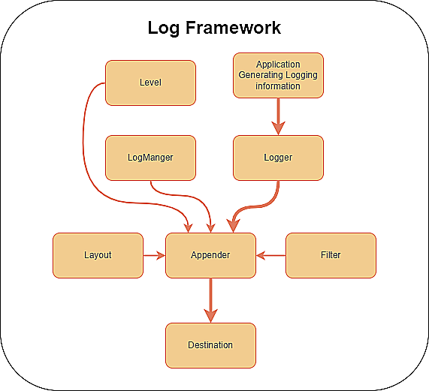

Logging in software refers to the process of capturing and recording relevant events, information, and errors that occur during the execution of a software application. It helps developers and administrators understand the behavior of the software, diagnose issues, and monitor its performance. Here are some key considerations when implementing logging in software:

1. Logging Frameworks/Libraries: Utilize logging frameworks or libraries available in the programming language you are using. These frameworks provide built-in functionality and features for logging, such as log levels, formatting, output destinations, and filtering.

2. Log Levels: Define different log levels to categorize the severity or importance of log messages. Common levels include DEBUG, INFO, WARN, ERROR, and FATAL. Assigning appropriate log levels to messages allows filtering and controlling the verbosity of the logs based on runtime configuration.

3. Log Messages: Log relevant events, errors, and information that provide valuable insights into the software's behavior. Include contextual information such as timestamps, thread/process IDs, source code locations, user interactions, and relevant data values. Ensure that log messages are clear, concise, and meaningful to aid in troubleshooting and analysis.

4. Output Destinations: Determine where log messages will be directed. Common destinations include console output, log files, databases, and remote log management systems. Consider the trade-offs between storage requirements, accessibility, security, and real-time analysis capabilities when selecting output destinations.

5. Log Rotation: Implement log rotation to manage log files effectively. Log rotation involves limiting the size of log files and archiving or deleting older log files. This helps prevent excessive disk usage, improves searchability, and maintains a manageable log history.

6. Error Handling and Exception Logging: Capture and log exceptions or error conditions encountered during the software's execution. Logging exceptions with detailed stack traces and relevant context information aids in diagnosing and resolving issues.

7. Configuration and Granularity: Allow flexibility in configuring the logging behavior through configuration files or runtime settings. Provide options to enable/disable logging, adjust log levels, and specify output destinations based on deployment requirements. Consider logging granularity by choosing appropriate log levels and determining the level of detail required for different log messages.

8. Performance Considerations: Logging can impact the performance of the software. Optimize logging operations to minimize overhead, especially in critical and high-performance systems. Techniques like asynchronous logging, batch processing, and conditional logging can be employed to enhance performance.

9. Security Considerations: Be cautious when logging sensitive or personally identifiable information (PII). Ensure that appropriate security measures are in place to protect the confidentiality and integrity of logged data. Consider anonymization or obfuscation techniques if necessary.

Communication Channel

Middleware refers to software components or services that sit between application components or systems, facilitating communication, integration, and data exchange. It acts as a bridge, enabling interoperability and abstraction of underlying complexities. Middleware provides a range of functionality, such as message routing, data transformation, security, and transaction management. Here are some common types of middleware used in software applications:

3. Remote Procedure Call (RPC): RPC middleware enables communication between distributed components by allowing them to invoke procedures or methods on remote systems. It abstracts the complexities of network communication, data serialization, and protocol handling. RPC frameworks often provide language-agnostic interfaces, enabling applications developed in different languages to communicate seamlessly.**Common Object Request Broker Architectur**e.

4. Web Services Middleware: Web services middleware supports communication and integration using web service protocols such as SOAP (Simple Object Access Protocol) and REST (Representational State Transfer). It enables applications to expose and consume services over the web, facilitating interoperability between heterogeneous systems. Web services middleware typically includes tools for service discovery, message parsing, security, and orchestration.

5. Database Middleware: Database middleware provides an abstraction layer between applications and databases, enabling standardized access and query operations. It offers features such as connection pooling, transaction management, and data caching, optimizing database access and performance.

6. Transaction Processing Middleware: Transaction processing middleware handles distributed transactions involving multiple resources or systems. It ensures the atomicity, consistency, isolation, and durability (ACID) properties of transactions. Transaction processing middleware coordinates and manages the flow of transactional operations, handling recovery and concurrency control..

7. Publish-Subscribe Middleware: Publish-subscribe middleware facilitates asynchronous communication between applications based on the publish-subscribe pattern. It allows publishers to publish messages to specific topics, and subscribers receive relevant messages by subscribing to topics of interest. Publish-subscribe middleware supports scalable and loosely coupled architectures.

